Supplementary material
Genome-wide analysis of Myo-inositol oxygenase gene family in tomato reveals their involvement in ascorbic acid accumulation

Shoaib Munir¹, Muhammad Ali Mumtaz¹, John Kojo Ahiakpa¹, Genzhong Liu¹, Weifang Chen¹, Guolin Zhou², Wei Zheng³, Zhibiao Ye^{1, 3}, and Yuyang Zhang ^{1, 3}*

¹ Key Laboratory of Horticultural Plant Biology, Ministry of Education, Huazhong Agricultural University, Wuhan 430070, China
² Wuhan Academy of Agricultural Sciences, Wuhan 430065, China
³ Huazhong Agricultural University Chuwei Institute of Advanced Seeds, Wuhan 430070, China
*Correspondence: Yuyang Zhang; Tel: +86 27 87283180; Fax: +86 27 87282010; Email: yyzhang@mail.hzau.edu.cn

Table S1. List of primer sequences.
Additional file 1. Primers used for real-time RT-PCR.
Gene | Full name | Accession No. | Forward primer (5'-3') | Reverse primer (5'-3')
SlMIOX4 | myo-inositol oxygenase gene | Solyc12g008650 | GAGAAAATGACTATTCTCATTGAGCAGCC | CCATGGATTCAATTACCACCTCAGC
GPI | glucose-6-phosphate isomerase | Solyc04g076090 | TGCTCTTCAAAAGCGTGTCC | CGGCAATAAGTGCTCTGTCA
PMI | phosphomannose isomerase | Solyc02g086090 | TACATTGTGGTGGAACGAGGA | ACCCCATTTGGCAAGAACAG
PMM | phosphomannomutase | Solyc05g048760 | TTTACCCTCCATTACATTGCTGA | TCTTCTTGACTACAGTTTCTCCCA
GMP1 | GDP-D-mannose pyrophosphorylase1 | Solyc03g096730 | AAACCTGAAATCGTGATGTGAGA | TGAAGAAGAGGAGAACTGGAAAC
GMP2 | GDP-D-mannose pyrophosphorylase 2 | Solyc06g051270 | TTGGACCAGATGTTGCGATA | CATTGTCCAACGGTTGAGTG
GMP3 | GMP synthase | Solyc07g006090 | AGATGAGGTGTGGGAAGTGC | TGCAGCTTCTGCAAATTCAC
GMP4 | GDP-Man 4 6-dehydratase | Solyc03g118270 | AAGATCGGGCTACAGAGCAA | GAACCAAATGCCTCTTCCAA
GME1 | GDP-Mannose 3′,5′-epimerase1 | Solyc01g097340 | AATCCGACTTCCGTGAGCC | CTGAGTTGCGACCACGGAC
GME2 | GDP-Mannose 3′,5′-epimerase2 | Solyc04g077020 | CCATCACATTCCAGGACCAGA | CGTAATCCTCAACCCATCCTT
GGP | GDP-L-galactose-1-phosphate phosphorylase1 | Solyc06g073320 | GAAATCTGGTCTGTTCCTCTGTGA | TTCACACACCAACTCCACATTACA
GPP | L-galactose-1-phosphate phosphatase1 | Solyc04g014800 | AGCCGCTACAAACCCTCATCT | TGTCCGCTTTCCATCTCCTAT
GalDH | L-galactose dehydrogenase | Solyc01g106450 | CTTCTTACTGAGGCTGGTGGTC | AACCTCTTTAACAGACTTCATCCC
GLDH | L-galactono-1,4-lactone dehydrogenase | Solyc10g079470 | ATTGAGGTTCCCAAGGACATAG | ATGTTATTAGATAGGATGCGGTTT
MDHAR | monodehydroascorbate reductase | Solyc09g009390 | GGTGATGTTGCCACTTTTCCTTT | CGACAGACTTCCCTTGCTCACT
DHAR | dehydroascorbate reductase | Solyc05g054760 | CCTACCTTCGTCTCATTTCCG | TGAACAAACATTCTGCCCATT
AO | ascorbate oxidase | Solyc04g054690 | AGGATGGCTCAGAGTGTT | ATCAGGTAAGGCGTATGG
cAPX | Cytosolic ascorbate peroxidase | Solyc06g005150 | TGGAGCCCATTAGGGAGCA | GCCAGGGTGAAAGGGAACAT
tAPX | thylakoid ascorbate peroxidase | Solyc11g018550 | CTTTCTTCAATGGCTTCTCTCACCG | CAACCTGGTAGCGAAACACATGGG
AOBP | ascorbate oxidase promoter-binding protein | Solyc06g69760 | GCTTTCTCCCATTGAACTCCAG | GCCAGCCACTTGCTCTTATTGT
ß-Actin | Solanum lycopersicum Actin | Solyc04g011500 | ATGGCAGACGGAGAGGATATTCA | AGACGGAGAATGGCATGTGG
Actin | Actin | Solyc11g005330 | GTCCTCTTCCAGCCATCCA | ACCACTGAGCACAATGTTACCG
Supplementary Figures legend

Fig. S1. Phylogenetic analysis of 5 MIOX proteins from S. lycopersicum with other species MIOX proteins.

Fig. S2. Alignment of 5 MIOX protein sequence from S. lycopersicum. Multiple sequence alignments were conducted using ClustalW2.
Figure S3. Chromosomal distribution of the SlMIOX genes. A total of 5 SlMIOX genes were mapped onto tomato chromosomes. The gene identity numbers are provided and respective chromosome numbers are shown at the top.

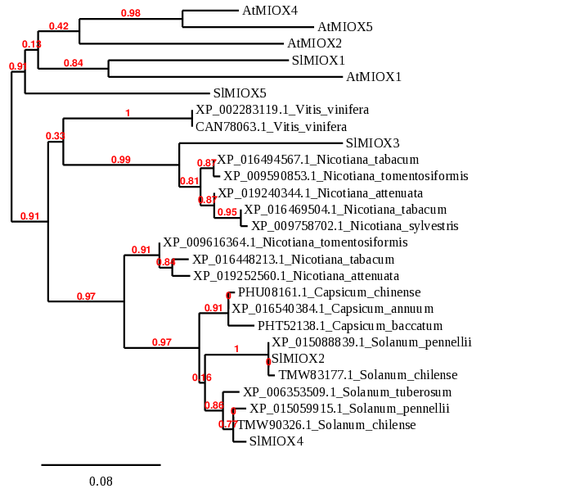
Figure S1

Figure S2

SlMIOX2 MAIVQALFPSQYLCMNKTKNNTQIGSKRSIQVSCRSSNQEDLLSRRQTSYNHSDEFGLQV
SlMIOX4 --------------MTILIEQPEFGSQ---------------VEEKKVSFN-ANELILDG
SlMIOX3 --------------MTFLVAQT------------------------------------DH
SlMIOX1 -------MRQVGPVLGRRKEECEIFDFS--------------SVFSFTMTILIEQLPVEI
SlMIOX5 ---------------------------------------------------------MTI

SlMIOX2 EVEEKKVASFNGNE---GVVFEVSNINAFGQSFRDYN-AKSERQKSVEEFYRVQHINQTY
SlMIOX4 GFMVPKTLSSQDE------IFEVPDINAFGQSFRDYN-VESERQKSVEEFYRVQHINQTY
SlMIOX3 ELDNKKAIS--DG------IFVVPGNNAFGNSFRDYN-AEAERQKIVRELYRQSHINQTY
SlMIOX1 QADETNIHAQNQKELVLGDGFAVPETNAFGHNFRDYT-VESARQQGVENFYKINHFNQTY
SlMIOX5 QLEGKKIQDQDQ--------FMVPQTNAFGHDFRDYNNAQSERQKGVEKFYKTQHINQTY
: * *. ****:.****. .:: **: *.::*: .*:****

SlMIOX2 DYVTKMRKEYGKLNKIEMSIWDCCELLNDVVDDSDPDLDEPQIEHLLQTAEAIRKDYPNE
SlMIOX4 DYVKKMRKEYGKLNKIEMSIWDCCELLNDVVDDSDPDLDEPQIEHLLQTAEAIRKDYPNE
SlMIOX3 DFVKKMREEYGKMNKVEMSIWECCELLNEVVDDSDPDLDEPQIEHLLQTAEAIRKDYPNE
SlMIOX1 DYVSKMRVEYAKLDKAEMSIWECCELLNDVVDDSDPDLDEPQIQHLLQSAEAIRKDYPDE
SlMIOX5 DFVKKMREDYIKLDKAKMSIWECCELLNDVVDDSDPDLDEPQIQHLLQSAEAIRKDYPNE
*:*.*** :* *::* :****:******:**************:****:*********:*

SlMIOX2 DWLHLTGLIHDLGKVLLHPSFGELPQWAVVGDTFPLGCAFDESIVHHKYFKENQDINNMI
SlMIOX4 DWLHLTGLIHDLGKVLLHPSFGGLPQWAVVGDTFPLGCAFDESIVHHKYFKENPDINNNI
SlMIOX3 DWLHLTGLIHDLGKVLLLPSFGGLPQWAVVGDTFPLGCAFDESIVLHEQLKGNPDNNNPT
SlMIOX1 DWLHLTALIHDLGKVLLLPSFGELPQWAVVGDTFPVGCAFHDSIVHSKYFKENPDYNNTA
SlMIOX5 DWLHLTALIHDLGKILVLPKFGGLPQWAVVGDTFPLGCAFDESNIHHKYFKENQDFNNPI
******.*******:*: *.** ************:****.:* : : :* * * **

SlMIOX2 YNTKNGVYEEGCGLNKVVMSWGHDDYMYLVAKENGTTLPYAALFVIRYHSFYALHKSGAY
SlMIOX4 YNTKNGVYEEGCGLDKVVMSWGHDDYMYLIAKENKTTLPSAALFVIRYHSFYALHRSGAY
SlMIOX3 YNTKYGVYSEGCGLNNVVMSWGHDDYMYLVAKANKTTLPSAALFIIRYHSFYRKQY----
SlMIOX1 YKSKFGVYSEGCGLDKVLMSWGHDDYMYLVAKENGTTLPSAGLFIIRYHSFYALHKSGAY
SlMIOX5 YNTKNGIYNDSIGLENVMMSWGHDDYMYMVAKENGTTLPSAGLFIIRYHSFYPLHKNGGY
*::* *:*.:. **::*:**********::** * **** *.**:******* :

SlMIOX2 KHLMNEEDKENIKWLNIFNKYDLYSKSSVRIDVENVKPYYLSLIQKYFPKILRW
SlMIOX4 THLMNEEDKENMKWLNIFNKYDLYSKSKVRIDVEKVKPYYLSLIEKYFPTKLRW
SlMIOX3 ----------------IINSFFLFSTT-----------YLL-------------
SlMIOX1 KELMNEEDKENLKWLHIFNKYDLYSKSKVQVNVEEVKPYYMSLIEKYFPAKLKW
SlMIOX5 KHLMNDEDEENLKWLHVFNKYDLYSKSKVHVNVEEVKPYYMSLIEKYFPAKLRW
::*.: *:*.: * :

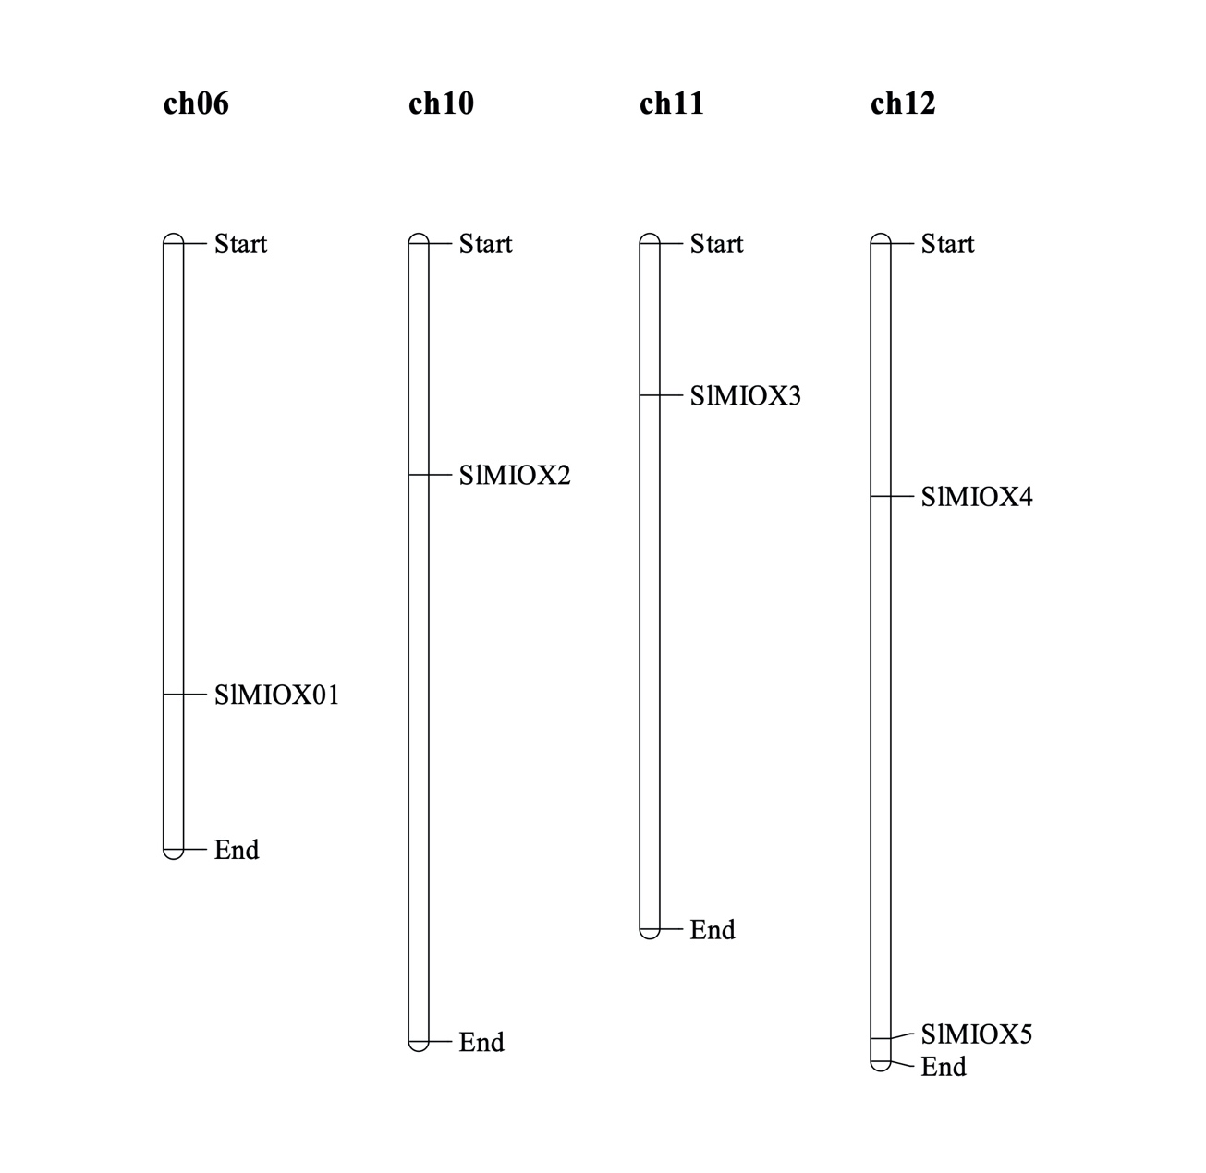
Figure S3

